Lab Experiment: Image Sharpening Using Laplacian Mask
Experiment No: 21
Aim
To perform sharpening of an image using a Laplacian mask implemented with diagonal neighbors.
Laplacian Mask
The given Laplacian mask is:
This mask uses 8-neighbor connectivity, including diagonal neighbors.
Tools Required
- Python 3.x
- OpenCV (cv2)
- NumPy
- VS Code / PyCharm / Jupyter Notebook
- Input image (image.jpg)
Procedure
- Install OpenCV and NumPy:
Bash
pip install opencv-python numpy
- Read the input image using OpenCV.
- Convert the image to grayscale.
- Define the Laplacian mask with diagonal neighbors.
- Apply the mask to the image using cv2.filter2D().
- Subtract the Laplacian result from the original image to obtain the sharpened image.
- Display the original, Laplacian, and sharpened images.
Code
import cv2
import numpy as np

# Read the image
image = cv2.imread("image.jpg")
# Check if image is loaded
if image is None:
print("Error: Image not found!")
exit(
# Convert image to grayscale
gray = cv2.cvtColor(image, cv2.COLOR_BGR2GRAY)
# Laplacian mask with diagonal neighbors
mask = np.array([
[1, 1, 1],
[1, -8, 1],
[1, 1, 1]
], dtype=np.float32)
# Apply Laplacian mask
laplacian = cv2.filter2D(gray, cv2.CV_32F, mask)

# Sharpen the image
sharpened = gray.astype(np.float32) - laplacian
# Convert values to valid 8-bit range
sharpened = np.clip(sharpened, 0, 255).astype(np.uint8)
# Display images
cv2.imshow("Original Image", gray)
cv2.imshow("Laplacian Image", cv2.convertScaleAbs(laplacian))
cv2.imshow("Sharpened Image", sharpened)

cv2.waitKey(0)
cv2.destroyAllWindows()
Output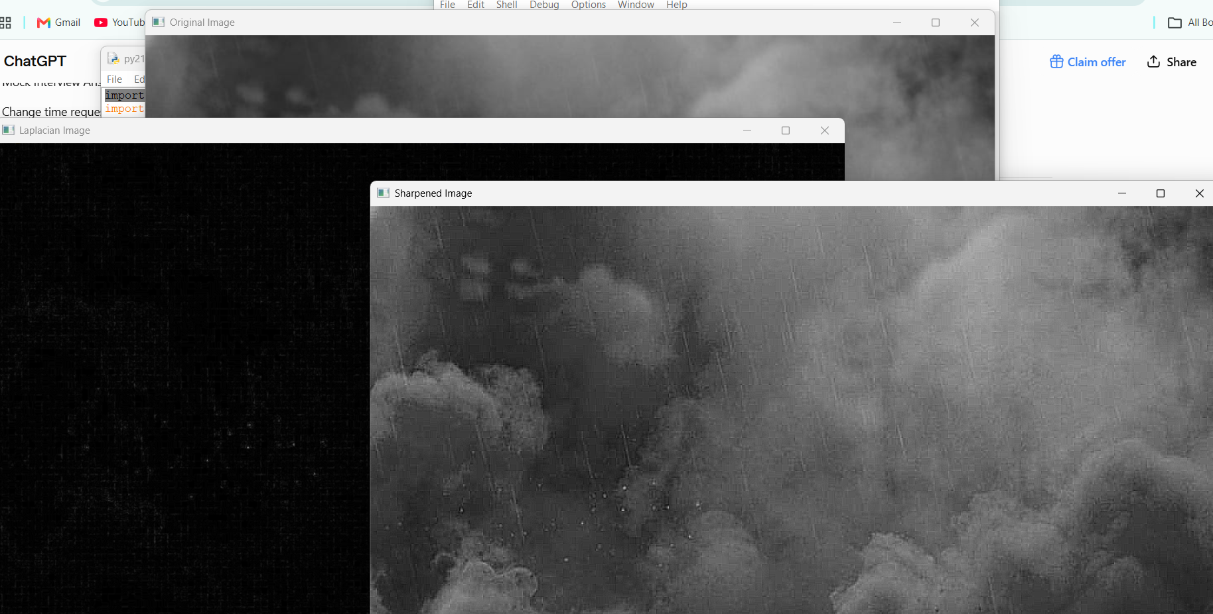
Result
The image was successfully sharpened using the Laplacian mask with diagonal neighbors. The mask
was applied successfully, and the resulting image showed enhanced edges and details.

